COMPANY PROFILE
Company Name: SuprMentr Technologies Private Limited

Year of Establishment: 2023

Address: 48, Church St,Haridevpur, Shanthala Nagar, Ashok Nagar, Bengaluru,
Karnataka –560001

Type of Company: Private Sector Organization

Mission Statement:
The mission of SuprMentr Technologies Private Limited is to bridge the gap between academic education and industry requirements by providing career mentorship, industry-oriented training, internship opportunities, and practical exposure to emerging technologies. The organization aims to empower students with technical, professional, and problem-solving skills required to excel in the modern workforce.

Clients:
St Engineering Students, Educational Institutions, Universities and Colleges, Fresh Graduates, Technology Learners ,Industry Professionals seeking Upskilling Opportunities.

Domains of Company Expertise:
- Career Mentorship and Guidance
- Internship and Industry Training Programs
- Cyber Security and Ethical Hacking
- Cloud Computing
- Professional Skill Development
- Placement Preparation and Career
- Web Development
- Software Development Training

SuprMentr Technologies Private Limited is a career-tech and ed-tech organization that focuses on providing industry-oriented training, internship opportunities, mentorship programs, and practical learning experiences for students. The organization helps students bridge the gap between academic education and industry requirements by offering hands-on exposure to emerging technologies, professional skill development, and real-world project implementation..

During the internship period, the organization provided practical exposure in the field of Cyber Security and Ethical Hacking, including web application security, vulnerability assessment, ethical hacking methodologies, cybersecurity best practices, and secure software development. Students were encouraged to work on innovative projects that address real-world cybersecurity challenges and promote secure digital environments..

As part of the internship, the project titled “Web App Security Testing Tool – Automate Testing for XSS and SQL Injection Vulnerabilities” was developed in the domain of Cyber Security and Ethical Hacking. The project focused on automating web application security assessment through SQL Injection detection, Cross-Site Scripting (XSS) testing, security header analysis, technology fingerprinting, port scanning, attack surface evaluation, and risk assessment. The system was designed to identify common security weaknesses in web applications and provide recommendations for improving security posture.

CHAPTER 2

INTERNSHIP DESCRIPTION
An internship is a professional learning experience that provides meaningful and practical exposure related to a student's academic background and career interests. It serves as an important platform for bridging the gap between theoretical concepts and real-world applications. Internships help students develop technical knowledge, problem-solving abilities, teamwork, communication skills, and professional discipline required in industry environments.

For students in the field of Cyber Security and Ethical Hacking, internships play a significant role in gaining practical experience in web application security, vulnerability assessment, ethical hacking methodologies, risk analysis, and secure software development practices. Such opportunities help students understand security testing methodologies, vulnerability detection techniques, penetration testing concepts, and implementation strategies used in real-world cybersecurity environments. Internships also encourage analytical thinking and provide exposure to solving security-related challenges using modern technologies..

Internships are beneficial for both students and organizations. While students gain practical knowledge, industry exposure, and professional experience, organizations are able to identify skilled and motivated individuals through project participation and teamwork. The internship experience also prepares students to adapt to workplace culture, deadlines, responsibilities, and collaborative environments, which are essential for future professional careers.

Outcomes:
- Upon successful completion of the internship, the intern will be able to:
- Apply theoretical and conceptual knowledge to practical Android application development projects.
- Demonstrate effective communication, teamwork, time management, and technical documentation skills.
- Gain practical exposure in web application security testing and vulnerability assessment.
- Understand the implementation of security scanning techniques such as SQL Injection and Cross-Site Scripting detection.
- Develop problem-solving abilities through innovative sustainability-focused applications.
- Document real-world cybersecurity use cases and develop solutions using modern technologies.

Organization: SuprMentr Technologies Private Limited

Nature of Work:
Industry-Oriented Cyber Security and Ethical Hacking Training with a focus on Web Application Security Testing, Vulnerability Assessment, Risk Analysis, and Secure Software Development.

Internship Project Title:
Web App Security Testing Tool – Automate Testing for XSS and SQL Injection Vulnerabilities"

Description of Internship Work:
The project focused on the development of a web-based security testing application capable of identifying common web application vulnerabilities and security misconfigurations. The application was designed to perform automated vulnerability assessment through SQL Injection testing, Cross-Site Scripting detection, security header analysis, technology fingerprinting, port scanning, attack surface evaluation, and security risk assessment..

The major contributions during the internship included:

- Designing and developing a modern web-based cybersecurity dashboard using HTML, CSS, and JavaScript.
- Developing the backend security assessment engine using Python and Flask.
- Implementing SQL Injection testing techniques for identifying potential database-related vulnerabilities.
- Implementing Cross-Site Scripting (XSS) detection mechanisms for analyzing input reflection behavior.
- Developing security header analysis modules to evaluate HTTP security configurations.
- Implementing technology fingerprinting techniques to identify web technologies used by target applications
- Developing open port scanning functionality for identifying exposed services.
- Creating risk scoring and attack surface analysis mechanisms for security evaluation.
- Performing application testing, debugging, optimization, and UI enhancement activities.

Internship Objectives:
- To gain practical experience in Cyber Security and Ethical Hacking concepts and methodologies.
- To understand and implement web application vulnerability assessment techniques.
- To develop automated testing mechanisms for SQL Injection and Cross-Site Scripting vulnerabilities.
- To design and implement security analysis modules such as header analysis, technology detection, and port scanning.
- To improve technical, professional, analytical, and problem-solving skills through real-world cybersecurity project development.
- To acquire industry-oriented development practices, teamwork exposure, and project implementation experience for future professional growth in Cyber Security and Secure Software Development..

CHAPTER 3

ON JOB TRAINING
During the internship period at SuprMentr Technologies Private Limited, practical exposure was provided in the field of Cyber Security and Ethical Hacking, with a focus on web application security, vulnerability assessment, security testing methodologies, and secure software development practices. The internship mainly focused on developing the project titled “Web App Security Testing Tool – Automate Testing for XSS and SQL Injection Vulnerabilities” using modern web technologies and cybersecurity concepts.

The on-job training helped in understanding the complete lifecycle of web application development and security assessment, including project planning, user interface design, vulnerability analysis, risk assessment, testing, debugging, and deployment. Practical implementation of security header analysis, SQL Injection detection, Cross-Site Scripting (XSS) testing, technology fingerprinting, attack surface evaluation, and port scanning techniques was carried out during the internship period.

The training also enhanced problem-solving ability, technical communication, teamwork, analytical thinking, and professional work discipline through continuous project development activities and real-world cybersecurity implementation practices.

TOOLS AND TECHNOLOGIES
The following tools and technologies were used during the internship project development:

Visual Studio Code
Visual Studio Code was used as the primary Integrated Development Environment (IDE) for developing, debugging, testing, and maintaining the web application.
Python

Python programming language was used as the core backend development language due to its simplicity, flexibility, and extensive support for web development and cybersecurity applications.

HTML5
HTML5 was used for designing the structure and layout of the web application interface.
CSS3
CSS3 was used for creating responsive layouts, modern dashboard interfaces, and improving the overall user experience of the application.

Firebase Authentication
Firebase Authentication was used for implementing anonymous user authentication and secure cloud access.

JavaScript
JavaScript was used to implement dynamic functionalities, asynchronous communication, and real-time interaction between the frontend and backend.

Requests Library

The Requests library was used for sending HTTP requests and analyzing web application responses during vulnerability assessment.

BeautifulSoup

BeautifulSoup was used for parsing HTML content and extracting information required for security analysis and technology detection.

GitHub
GitHub was used for project version control, source code management, and project documentation.

LANGUAGES LEARNT
The internship helped in improving knowledge and practical implementation skills in the following programming and web technologies:

Python

Python was the primary programming language used for developing the security scanner, vulnerability assessment modules, backend processing, and risk analysis functionalities.

HTML

HTML was used for designing and structuring the web application's user interface and dashboard components.

CSS

CSS was used for styling the application, implementing responsive layouts, and creating a modern cybersecurity-themed dashboard.

SQL Concepts

Basic SQL concepts and database security principles were learned while understanding SQL Injection vulnerabilities and secure database interaction practices.

SKILLS ACQUIRED
The internship provided practical exposure and helped in acquiring various technical and professional skills.

Technical Skills Acquired
    - Web Application Security Testing
    - Vulnerability Assessment
    - SQL Injection Detection
    - Cross-Site Scripting (XSS) Analysis
    - Security Header Analysis
    - Technology Fingerprinting
    - Open Port Scanning
    - Risk Assessment and Scoring
    - Flask Web Development
    - Frontend Development using HTML, CSS, and JavaScript
    - Debugging and Error Handling

Professional Skills Acquired
    - Teamwork and Collaboration
    - Communication Skills
    - Problem Solving Ability
    - Time Management
    - Technical Presentation Skills
    - Project Planning
    - Professional Discipline
    - Analytical Thinking
    - Adaptability to New Technologies

The on-job training experience significantly improved both technical competency and professional confidence, helping in understanding industry-oriented cybersecurity practices, web application security assessment methodologies, and secure software development principles.

CHAPTER 4

USECASE IMPLEMENTATION
  - PROBLEM DEFINITION
Web applications play a critical role in today’s digital ecosystem, supporting key industries such as education, banking, healthcare, e-commerce, and government services. Their widespread use and internet accessibility make them highly attractive targets for cyber attackers aiming to exploit security weaknesses. As reliance on web applications continues to grow, ensuring their security has become increasingly important to protect sensitive data and maintain system integrity.

Common vulnerabilities, including Cross-Site Scripting (XSS), SQL Injection (SQLi), insecure configurations, missing security headers, and exposed network services, pose serious risks. These weaknesses can lead to unauthorized access, data breaches, information leakage, and full system compromise. However, many organizations—especially small businesses and educational institutions—often lack the necessary tools and expertise to identify and address these vulnerabilities early in the development lifecycle.

To overcome these challenges, the project “Web App Security Testing Tool – Automate Testing for XSS and SQL Injection Vulnerabilities” was developed. This tool offers an automated approach to security assessment by performing tasks such as SQL Injection testing, XSS detection, security header analysis, technology fingerprinting, port scanning, and attack surface evaluation. It provides a user-friendly, web-based platform that enhances security awareness, helps identify common vulnerabilities, and delivers actionable recommendations to strengthen the overall security posture of web applications.

  - ARCHITECTURE DIAGRAM
SYSTEM ARCHITECTURE DIAGRAM CONTENT
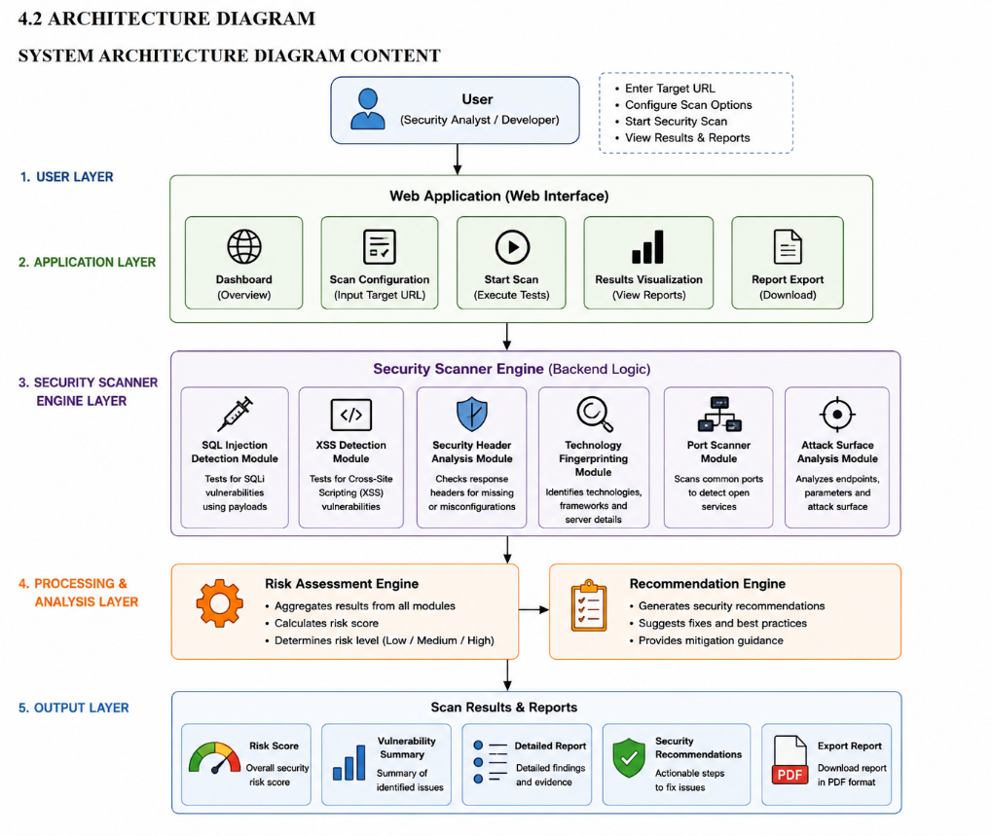

Components include in diagram:

User Layer
    - User(Security Analyst/Developer)

Application Layer
    - Displays scan statistics
    - Shows recent scans and summaries

Security Scanner Layer
    - SQL Injection Detection Module
    - Cross Site Scripting(XSS) Detection Module
    - Security Header Analysis Module
    - Technology Fingerprinting Module
    - Port Scanner Module
    - Attack Surface Analysis Module

Processing & Analysis Layer
    - Risk Assessment Engine
    - Recommendation Engine

Output Layer
    - Risk Score
    - Vulnerability Summary
    - Detailed Report
    - Security Recommendations
    - Export Report
  - SOFTWARE AND HARDWARE REQUIREMENTS SOFTWARE REQUIREMENTS
Software | Purpose
Python 3.14 | Core Programming Language
Flask | Backend Programming Language
HTML5 | Frontend Structure
CSS3 | User Interface Styling
JavaScript | Client-Side Functionality
Tailwind CSS | Responsive UI Design
MySQL | Database Management
Nmap | Port Scanning and Network Analysis
GitHub | Version Control

HARDWARE REQUIREMENTS
Hardware | Specification
Laptop/PC | Minimum 8GB RAM
Display | 1366 x 768 Resolution or Higher
Internet Connection | Required
Processor | Intel i5 or above
Storage | Minimum 20GB Free Space

  - FUNCTIONAL AND NON FUNCTIONAL REQUIREMENTS FUNCTIONAL REQUIREMENTS
Requirement ID | Functional Requirement
FR1 | Enter and Validate Target URL
FR2 | Configure Security Scan Options
FR3 | Perform SQL Injection Testing
FR4 | Perform SQL Injection Testing
FR5 | Analyze HTTP Security Headers
FR6 | Perform Technology Fingerprinting
FR7 | Conduct Port Scanning
FR8 | Analyze Attack Surface
FR9 | Generate Risk Assessment Score
FR10 | Generate Security Recommendations
FR11 | Display Scan Results Dashboard
FR12 | Export Security Reports in PDF Format

NON-FUNCTIONAL REQUIREMENTS

Requirement ID | Non Functional Requirement
NFR1 | User Friendly Interface
NFR2 | Fast Scan Performance
NFR3 | Scalability for Multiple Scans
NFR4 | High Reliability
NFR5 | Secure Data Processing
NFR6 | Responsive Web Interface
NFR7 | Report Generation Efficiency
NFR8 | Cross-Browser Compatibility
NFR9 | Availability and Accessibility
NFR10 | Maintainability and Extensibility

  - USE CASE DIAGRAMS
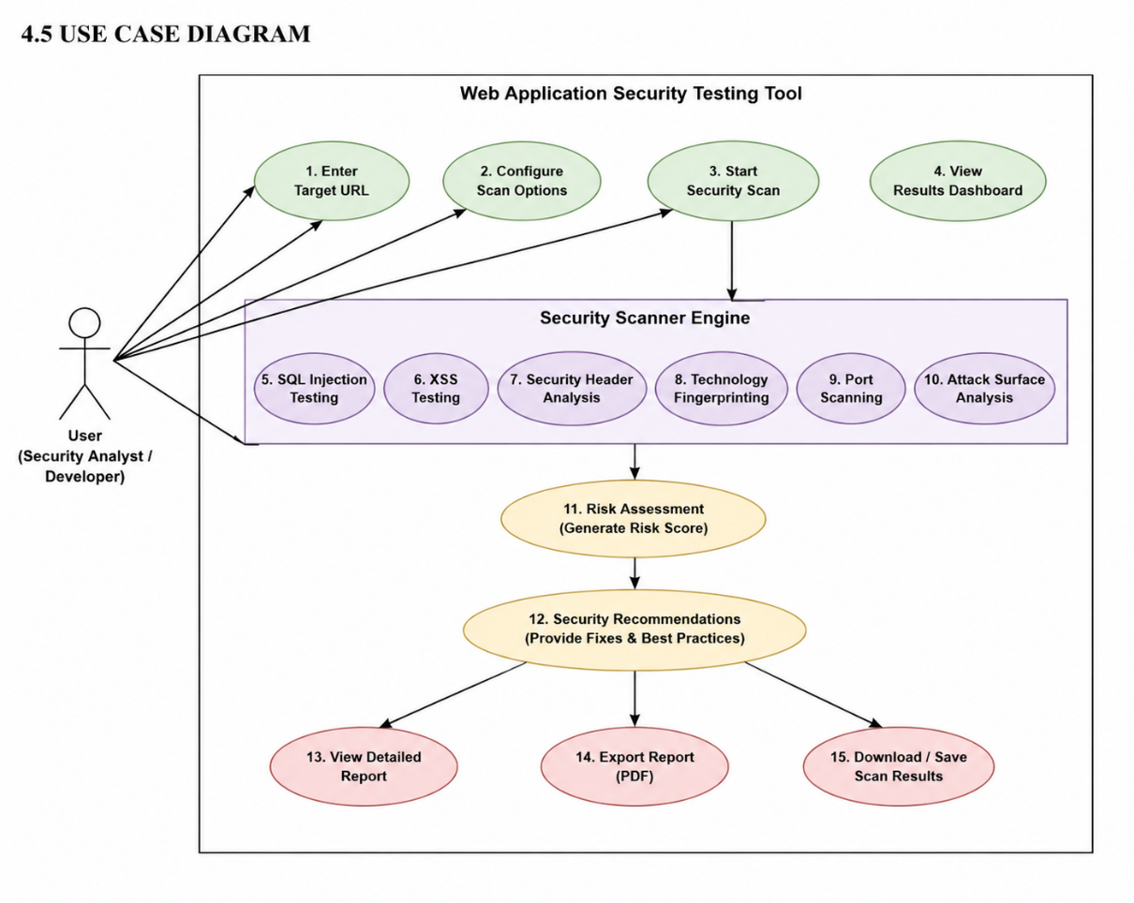

4.6 DFD (DATA FLOW DIAGRAM) DFD FLOW
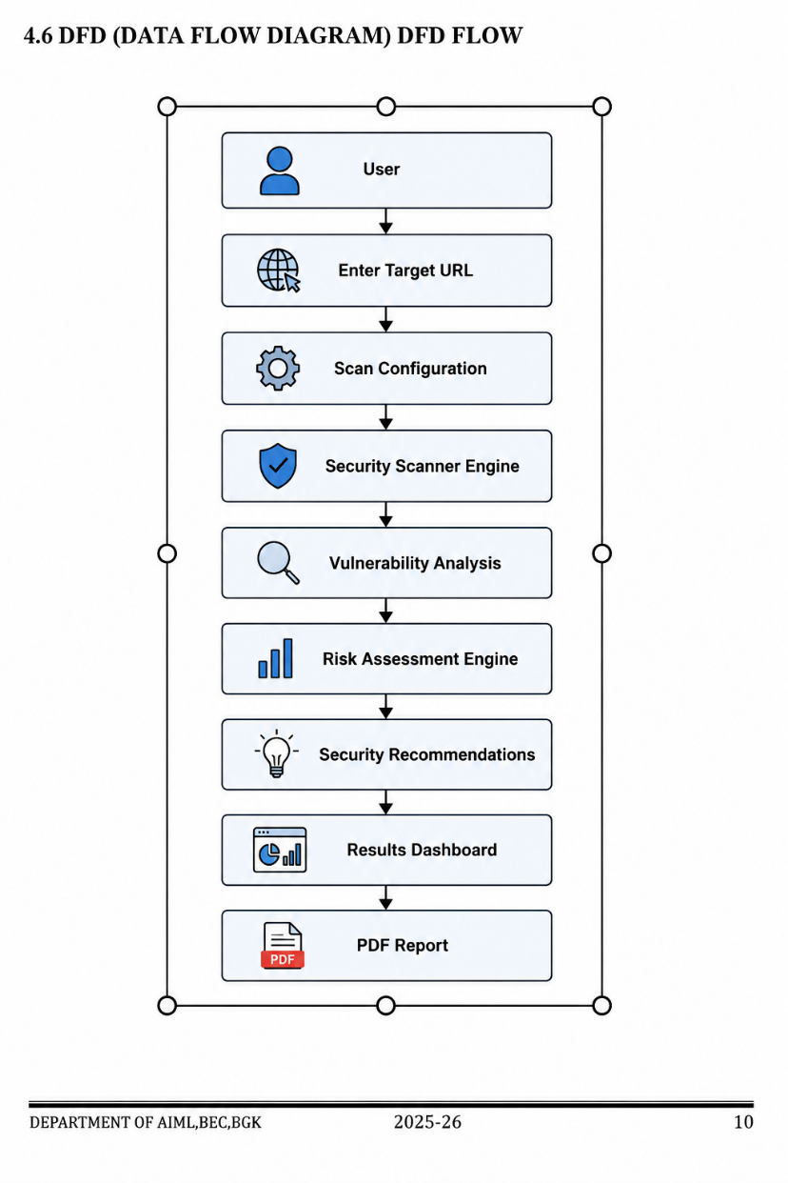

DFD COMPONENTS

External Entity

    - User(Security Analyst / Developer)

Process

    - Target URL Input
    - Scan Configuration
    - Security Scanning
    - Vulnerability Analysis
    - Risk Assessment
    - Recommendation Generation
    - Report Generation

Data Store

    - Temporary Scan Results
    - Generated Reports

Output

    - Vulnerability Summary
    - Detailed Security Report
    - Risk Assessment Score
    - Security Recommendations
    - Exported PDF Report

CHAPTER 5

CODE SNIPPETS

Flask Application Initialization

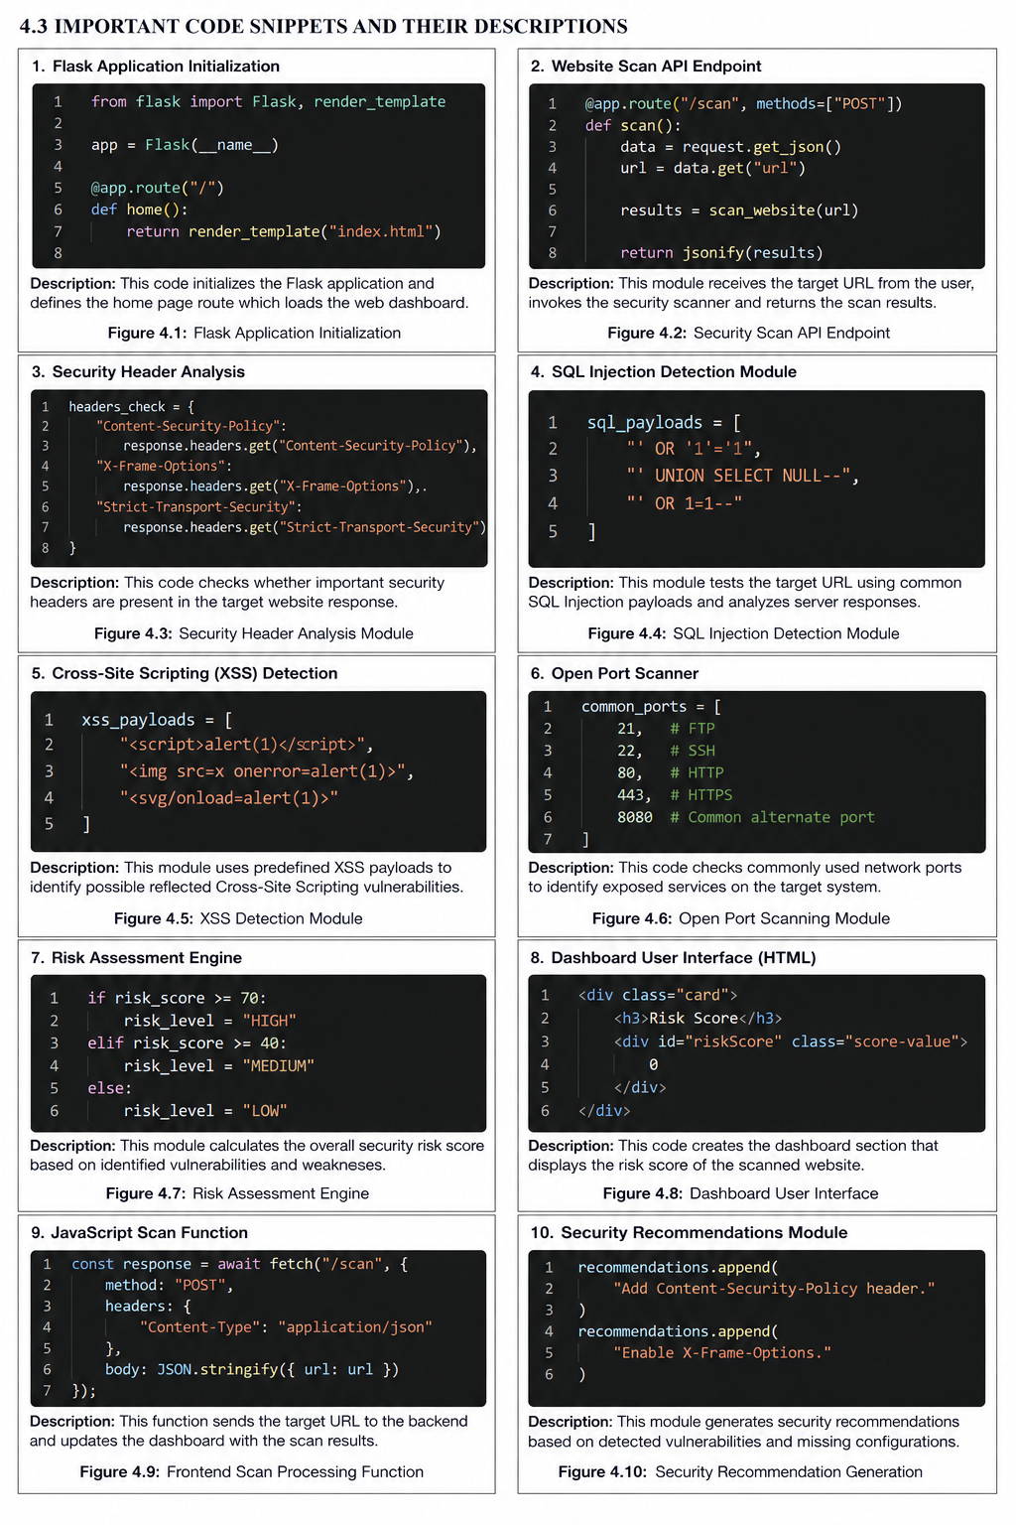

Website Scan API Endpoint



Security Header Analysis



SQL Injection Detection Module



Cross-Site Scripting (XSS) Detection



Open Port Scanner



Risk Assessment Engine



Dashboard User Interface(HTML)



JavaScript Scan Function



Security Recommendations Module



CHAPTER 6

SCREENSHOTS
This chapter presents the important screenshots of the “Anthar-Jala Watch – Smart Groundwater Monitoring and Sustainability Platform” developed during the internship period. The screenshots demonstrate the implementation of realtime groundwater monitoring, Google Maps visualization, GIS-inspired heatmap rendering, Firebase integration, and analytics dashboard functionalities.

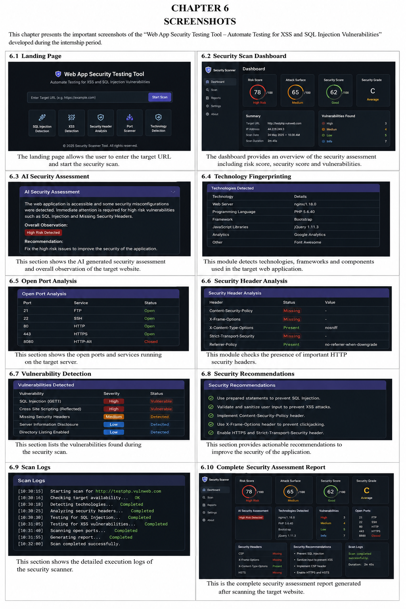
Landing Page

Security Scan Dashboard



AI Security Assessment



Technologies Fingerprinting



Open Port Analysis



Security Header Analysis



Vulnerability Detection



Security Recommendation




Scan Logs

Complete Security Assessment Report



CHAPTER 7
INTERNSHIP SUMMARY AND CONCLUSIONS

The internship at SuprMentr Technologies Private Limited provided valuable practical exposure in the field of Cyber Security and Ethical Hacking, web application security testing, vulnerability assessment, and secure software development practices. The internship mainly focused on the development of the project titled “Web App Security Testing Tool – Automate Testing for XSS and SQL Injection Vulnerabilities”, which was designed to identify common web application security weaknesses and provide automated security analysis through a user-friendly web-based platform.

During the internship period, practical knowledge was gained in Python programming, Flask web development, frontend development using HTML, CSS, and JavaScript, and cybersecurity assessment methodologies. The internship helped in understanding the complete software development lifecycle including project planning, system design, user interface development, security testing, debugging, performance optimization, and deployment. Practical implementation of security header analysis, SQL Injection detection, Cross-Site Scripting (XSS) testing, technology fingerprinting, attack surface evaluation, and open port scanning techniques provided valuable hands-on cybersecurity experience.

The project focused on automating web application security assessment by analyzing target websites and identifying potential vulnerabilities and security misconfigurations. Security header evaluation, vulnerability detection, risk assessment, technology identification, and recommendation generation modules were successfully developed and tested during the internship period. The project also improved understanding of web security principles, HTTP communication, network security concepts, and vulnerability assessment methodologies used in real-world cybersecurity environments.

The internship experience also provided exposure to practical cybersecurity challenges and security assessment approaches used to strengthen the security posture of web applications. The project demonstrated how modern web technologies and security testing techniques can be used to identify vulnerabilities, assess risks, and provide actionable recommendations for improving application security.

Overall, the internship was highly beneficial in strengthening technical competency, cybersecurity awareness, professional discipline, and practical industry exposure. The knowledge and experience gained during the internship will be valuable for future academic projects, cybersecurity research activities, ethical hacking practices, and professional career development in the fields of Cyber Security, Ethical Hacking, Secure Software Development, and Information Security.

Future enhancements to the project may include advanced vulnerability assessment techniques, integration with Artificial Intelligence for intelligent threat analysis, support for additional security testing modules, automated report generation, and enhanced penetration testing capabilities. These improvements can further increase the effectiveness of the system in identifying and mitigating web application security risks.

CONCLUSION
The internship carried out at MindMatrix was a valuable learning experience that provided practical exposure to Android application development and realtime cloud-based systems. The successful implementation of the project “Anthar-Jala Watch – Smart Groundwater Monitoring and Sustainability Platform” demonstrated the application of Android technologies, Firebase integration, Google Maps SDK, and GIS-inspired visualization techniques for solving real-world environmental monitoring problems.

The project successfully achieved its objective of developing a smart groundwater monitoring platform capable of realtime borewell data collection, heatmap visualization, and sustainability analytics. The internship also enhanced practical understanding of software development methodologies, realtime database integration, map visualization systems, and mobile application deployment.

The overall internship experience contributed significantly towards technical skill enhancement, professional growth, and industry-oriented learning, thereby creating a strong foundation for future career opportunities in software development and emerging technologies.

REFERENCES

Reference to Android Development Documentation

Android Developers (2025), Android Developer Documentation, Google Developers, Available at: https://developer.android.com

Reference to Firebase Documentation

Firebase Documentation (2025), Firebase Firestore and Firebase Authentication Documentation, Google Firebase Platform, Available at: https://firebase.google.com/docs

Reference to Google Maps SDK Documentation

Google Developers (2025), Google Maps SDK for Android Documentation, Google Developers Platform, Available at: https://developers.google.com/maps/documentation/android-sdk

Reference to Jetpack Compose Documentation

Android Developers (2025), Jetpack Compose Documentation, Google Developers, Available at: https://developer.android.com/jetpack/compose

Reference to Kotlin Documentation

JetBrains (2025), Kotlin Programming Language Documentation, Kotlin Official Website, Available at: https://kotlinlang.org/docs/home.html

Reference to Material Design Documentation

Google Developers (2025), Material 3 Design Guidelines for Android Applications, Available at: https://m3.material.io

Reference to Journal Paper

Sharma, P., Verma, R. and Kulkarni, S. (2022), Smart Groundwater Monitoring using GIS and Mobile Technologies, International Journal of Environmental Research and Technology, Vol. 8(3), pp. 45-52.

Reference to Conference Paper

Patil, A. and Kumar, N. (2023), Realtime Environmental Monitoring using Android and Cloud Integration, Proceedings of International Conference on Smart Sustainable Technologies, Bengaluru, India.

Reference to Text Book

Pressman, R. S. (2010), Software Engineering: A Practitioner’s Approach, McGraw-Hill Education, New York.

Reference to Website

- Android Studio Official Website, accessed 12. v. 2026: https://developer.android.com/studio

- Firebase Official Website, accessed 14. v. 2026: https://firebase.google.com

- Google Maps Platform Documentation, accessed 16. v. 2026: https://developers.google.com/maps

- Kotlin Official Website, accessed 18. v. 2026: https://kotlinlang.org

- GitHub Official Website, accessed 20. v. 2026: https://github.com

